**HTML Report Generation for SoapUI XML Execution**

## **Pre Requirements:**

1. IntelliJ IDEA Community Edition.
2. Gauge and Java Language Runner.
3. HTML Report Plugin (Please refer “Installing Gauge and IntelliJ IDEA Community Edition” documentation for further knowledge)
4. Apache Maven
5. SoapUI Free Version (v4.5.1 or above)

## **Getting Started**

1. Open IntelliJ IDEA Community Edition and Click “Create New Project”

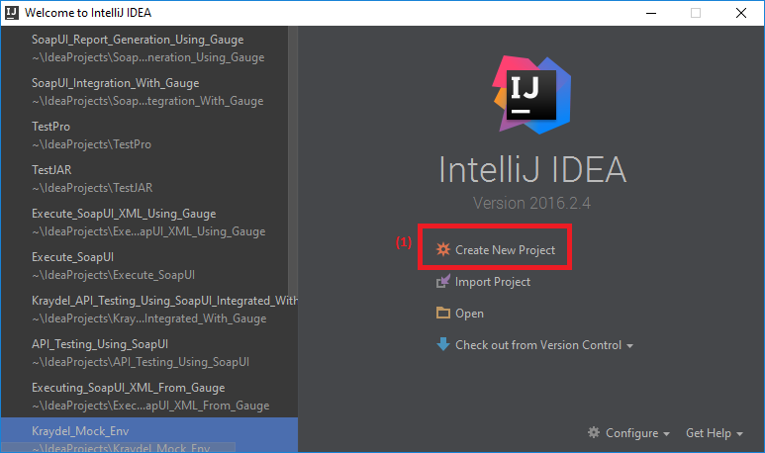

1. 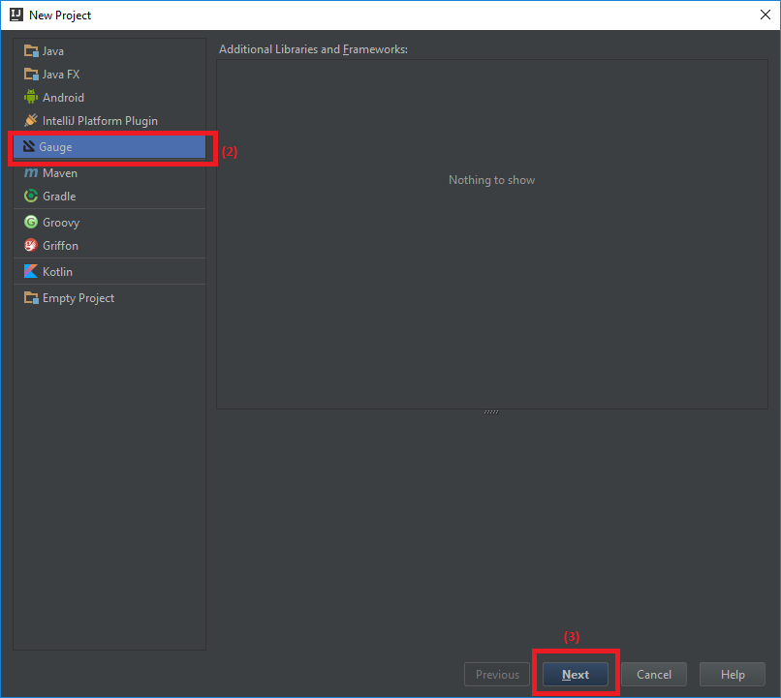Select “Gauge” and Click “Next” button
2. 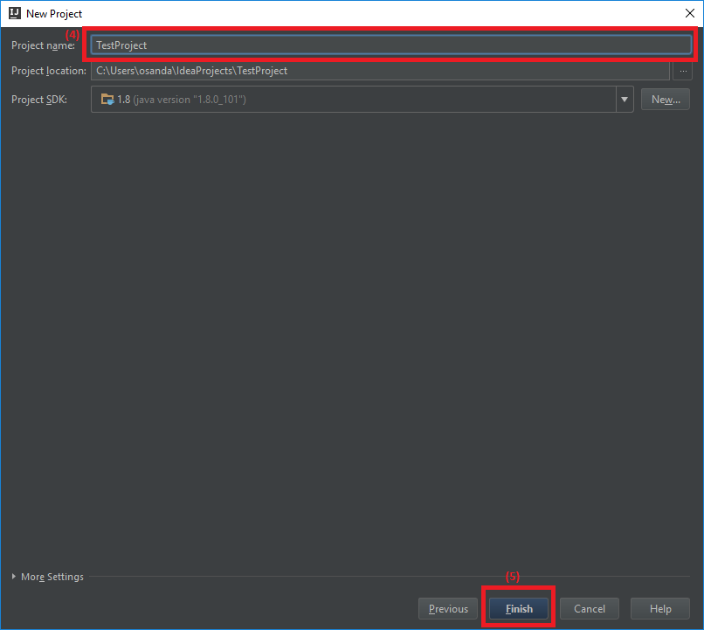Enter a name for the project and Click “Finish” button

1. Download this RAR from [here](https://drive.google.com/file/d/0BxipNkUcDIYFaEpJU09lVzJ4bTA/view?usp=sharing)
2. Extract it
3. Please verify you have following folders in the extracted folder  
   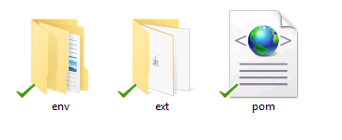
4. Copy these two folders and pom.xml file
5. 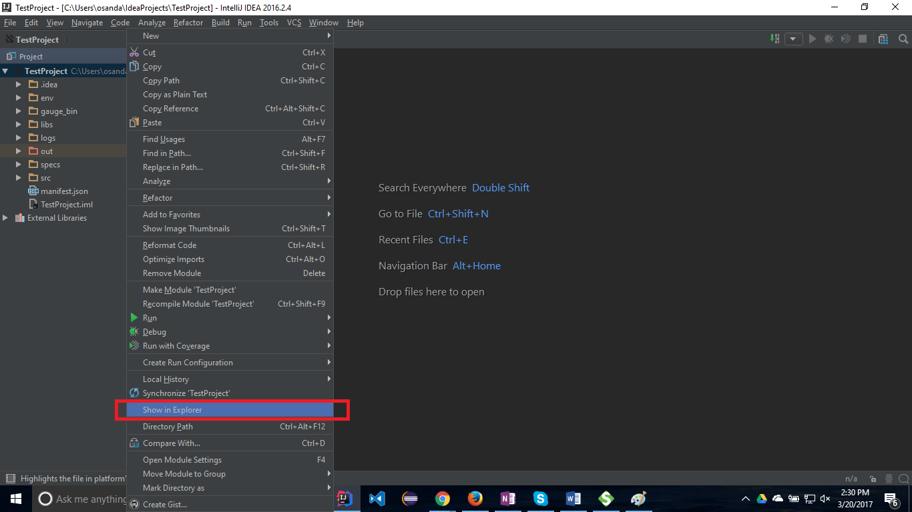Open your project in “Windows Explorer”
6. Go inside the project “TestProject”
7. Paste the above files into this location (Confirm to replace files)
8. Go to IntelliJ IDEA IDE
9. 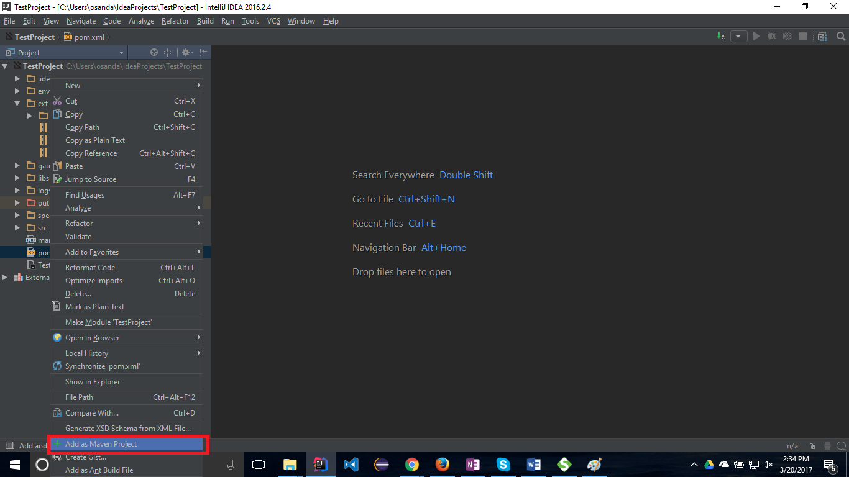Right Click on pom.xml and click “Add as Maven Project”
10. 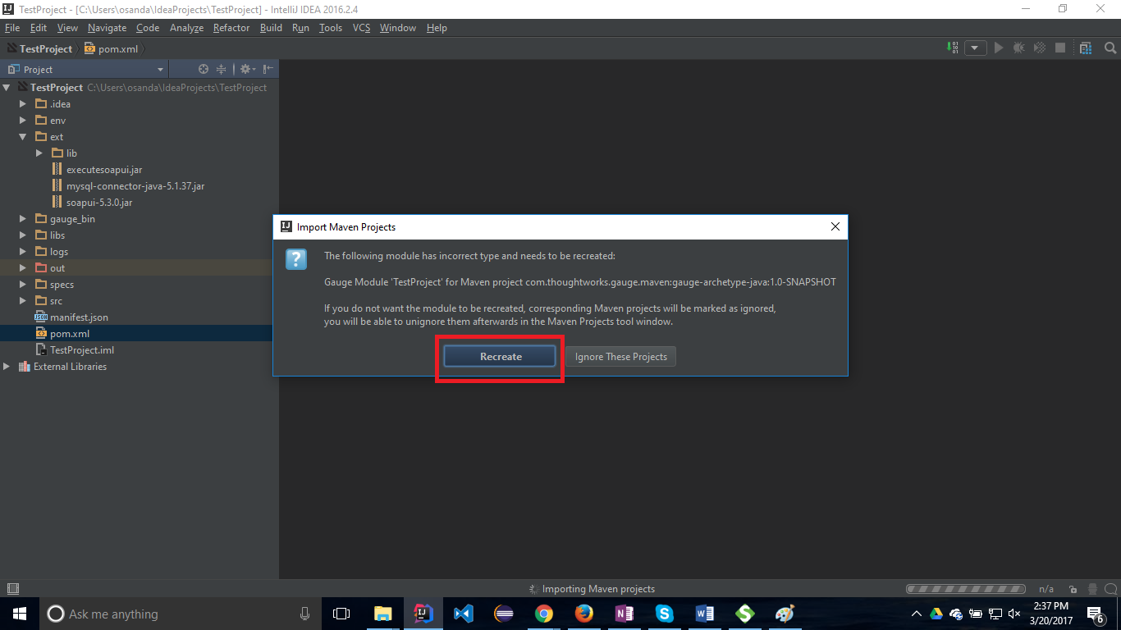Click “Recreate” button
11. Again Right Click on pom.xml and click “Add as Maven Project”
12. 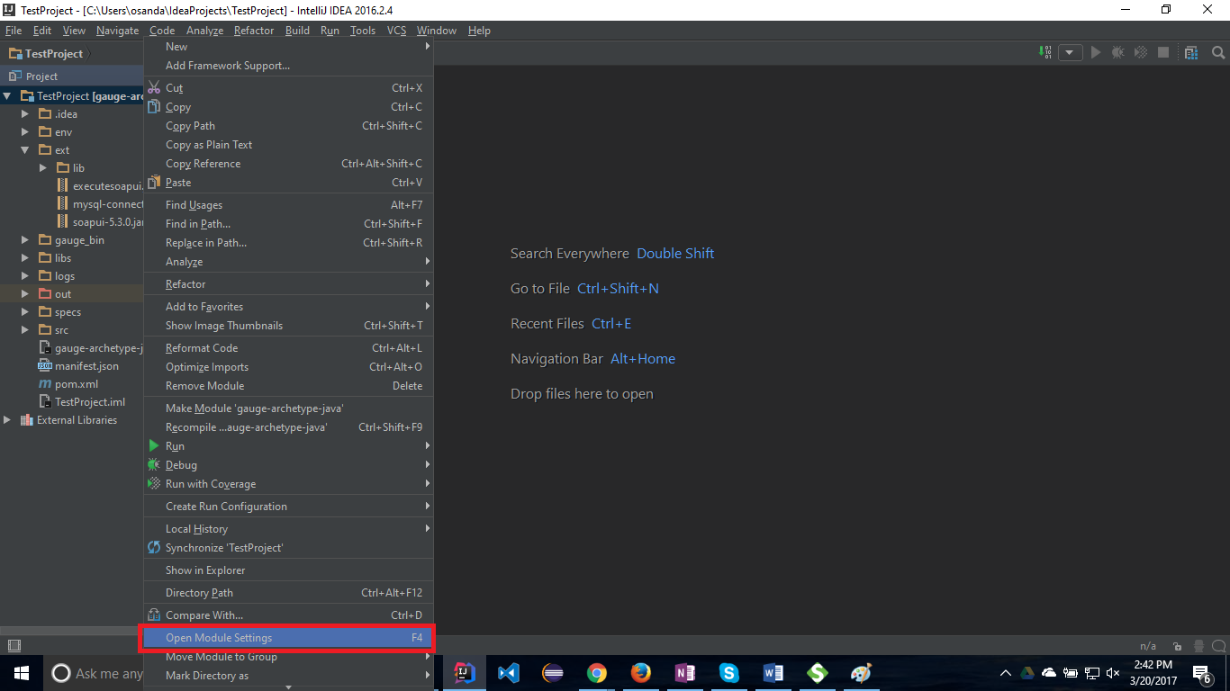Right Click on “TestProject” and click “Open Module Settings”
13. Select “Libraries” from the left section
14. 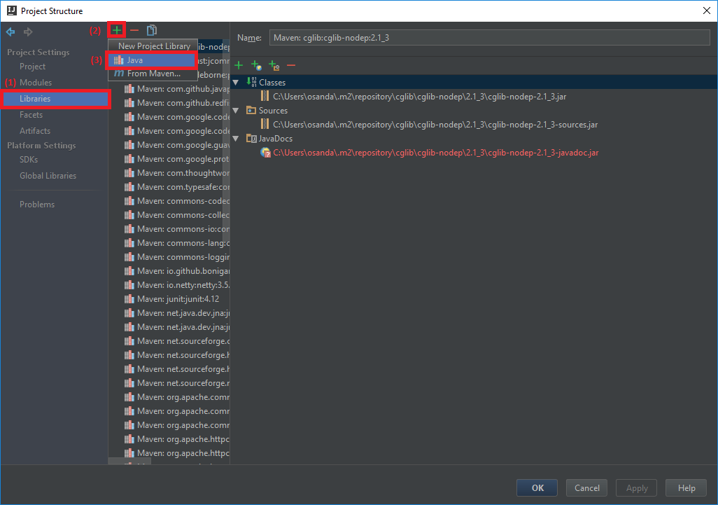Click on the “**+**” from the top of the window and click “Java”

1. 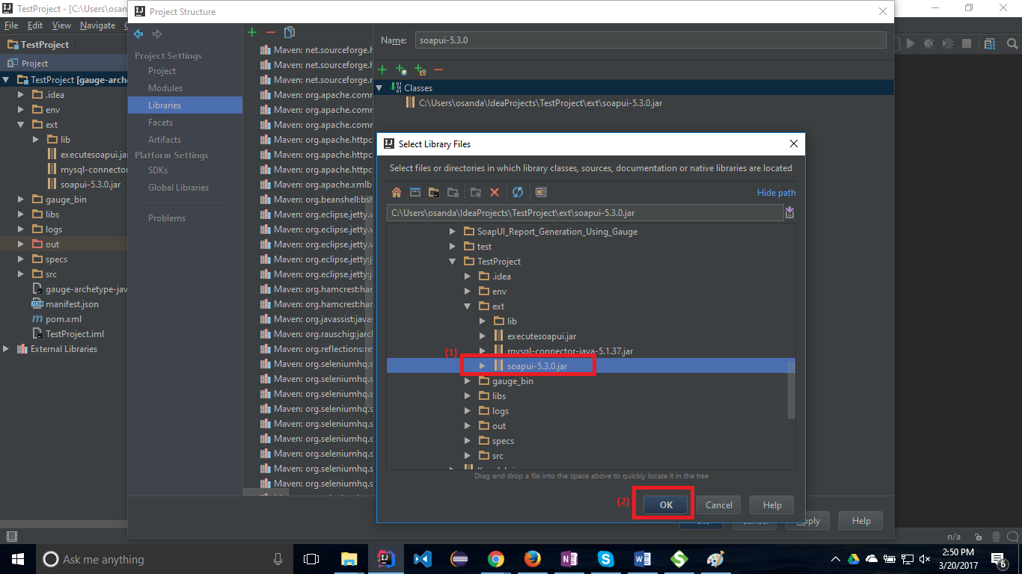Browse “ext” folder inside your project and select “soapui-5.3.0” JAR file
2. Click Ok
3. 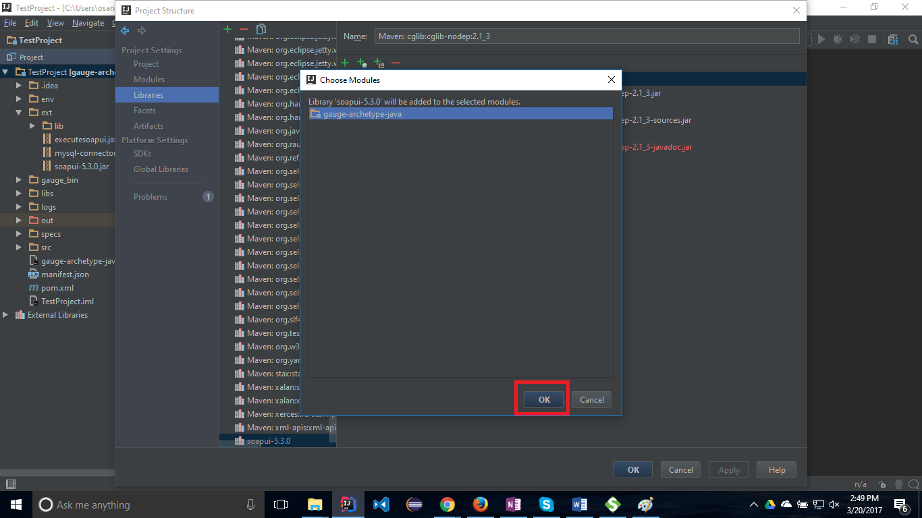Click Ok
4. Similar to that, add “mysql-connector-java-5.1.37” and “executesoapui” JARs inside the “ext” folder one by one
5. Then add “libs” folder inside the “ext” folder
6. 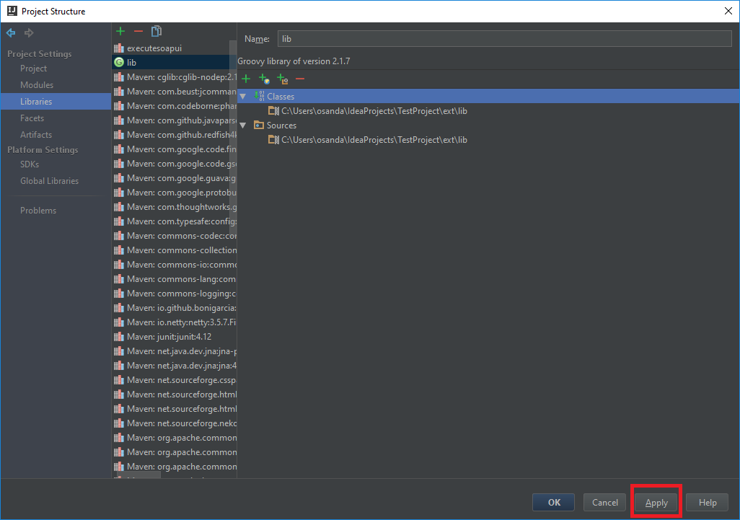Click “Apply” button
7. Click “Ok” button

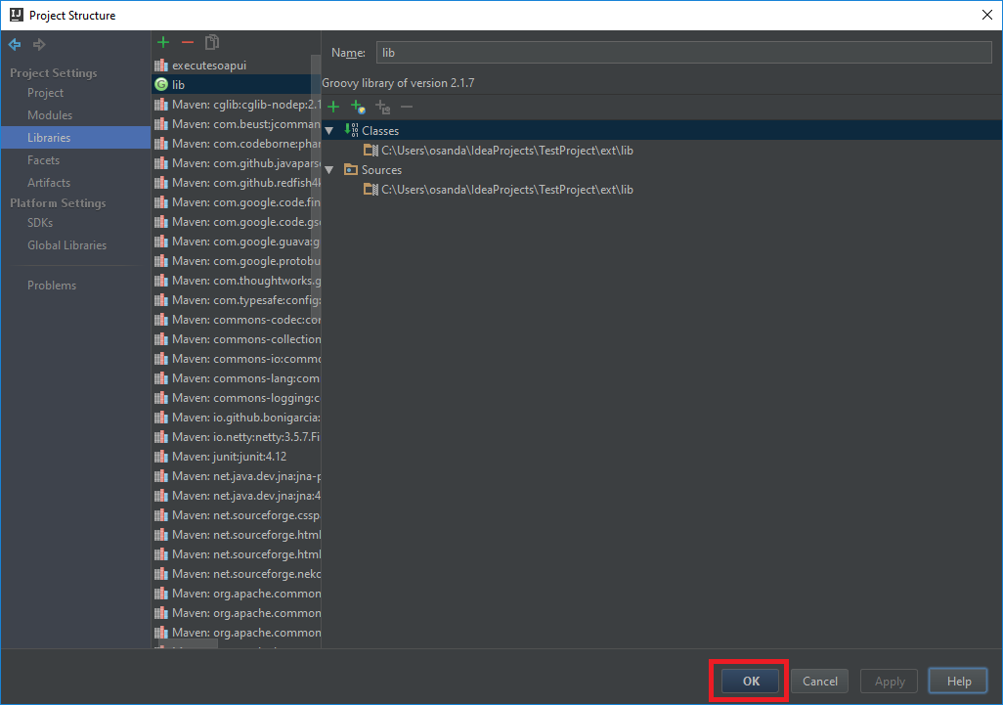

1. Expand “src” folder on “TestProject” and delete the “StepImplementation.Java” file
2. Right click on “java” folder and add a new Java class
3. In that Java file, add following code snippet

import com.osanda.ExecuteSoapUIAnyTestCase;  
import com.thoughtworks.gauge.Step;  
  
*/**  
 * Created by Osanda on 3/20/2017.  
 */*public class Test {  
 @Step("Execute <testCase> of <testSuite>")  
 public void testm(String testCase, String testSuite) throws Exception {   
 ExecuteSoapUIAnyTestCase executeSoapUIAnyTestCase = new ExecuteSoapUIAnyTestCase();  
 executeSoapUIAnyTestCase.executeSpecificTestCase(testCase, testSuite);  
 }  
}

1. Expand “env” folder on “TestProject” and open “default.properties” file
2. Change the “SOAPUI_XML_PATH” property value into the location of your SoapUI XML file
3. Expand “specs” folder on “TestProject” and delete the “example.spec” file
4. Right click on “spec” folder and add a new Specification
5. In that Specification file, add following lines

**Specification Heading  
=====================**Created by Osanda on 3/20/2017  
  
This is an executable specification file which follows markdown syntax.  
Every heading in this file denotes a scenario. Every bulleted point denotes a step.  
   
Scenario Heading  
----------------  
* Execute "Login Existing User With Correct Username & Empty Password TestCase" of "LoginTestSuite"

1. 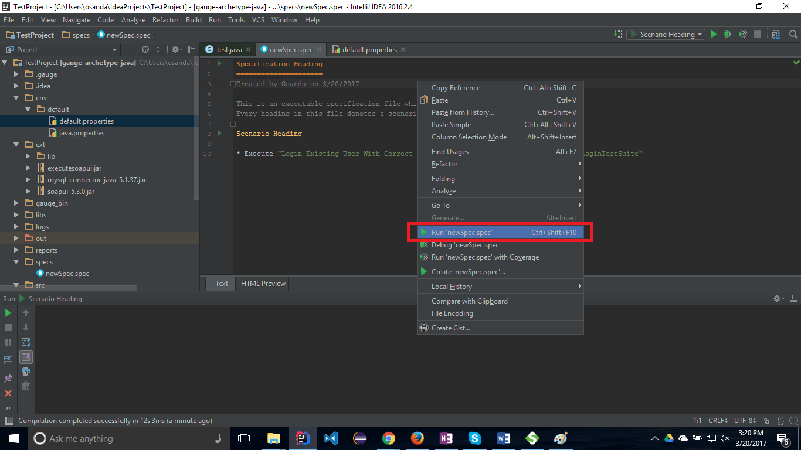Right click on the specification and click “Run ‘your_spec.spec’”

Date Created : 03/20/2017

Version : 1.0.0

Owner : Osanda Deshan <onimalarathna@mitrai.com>

Description : HTML Report Generation for SoapUI XML Execution